Morning session with Mosaic: Reflect on the Saint Louis Zoo with Stock and Flow

Time | Activity | Steps | Point Person | Materials
8:30-8:35 | Transition In and Do Now | - Introduce myself  - “I’m a social work student at WashU, and I’ll be leading the session this morning…”  - Do-Now: Use one word to describe your experience at the zoo  - Take 3-5 answers  - Use the answers to transition into the next section | Xinyuan
8:35-8:45 | Introduce Stock and Flow | - Briefly introduce the stock and flow model  - Start with the bath analogy: “Have we used a bath tab before?”  - “Bathtub has water in it.” “To add water, you turn on the faucet, and water flows in.” “How can we lower the water level?” “Yes, you drain it, that’s water flowing out.”  - Label components of the model: stock, inflow, and outflow  - “Stock can also be an abstract idea.”  - Prompt: What makes the zoo great? That is, what makes people want to go to the zoo  - Relabel the bathtub as “zoo greatness”  - “Today we define great as easy to go and fun.”  - Give an example of how to add a variable to inflow & outflow  - Give an example of how to connect two variables -> think in thumbs  - For example, parking spots influence inflow, but when zoo becomes better, more people come, and there are fewer spots -> loop  - Split students into groups and distribute poster boards | Xinyuan | - Whiteboard  - Markers
8:45-8:55 | Group Work | - Walk around the room, clarify steps, and answer questions  - Give time prompts | Xinyuan | - Poster boards
8:55-9:00 | Closing | - Let each group briefly share their thoughts  - Collect finished poster boards | Xinyuan

Potential variables: perception of crowds, highway access, transportation, parking spot, variety of animals, seasonal exhibitions, free admission, etc.
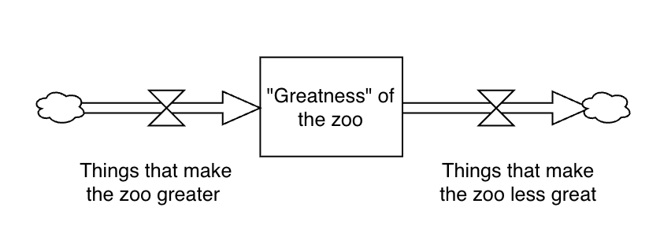
script (not really applicable): https://en.wikibooks.org/wiki/Introducing_Stock_and_Flow

